Week2 Module2 Assignment1
This assignment focuses on implementing a relational database using PostgreSQL and understanding how data is structured and managed. The objective was to create a database, implement a schema, load data from a CSV file, and generate a backup file. This process helped me understand how relational databases are used in real-world applications, especially in data management and analysis.
1. Analysis of Table Structure and Data Types
A. Column Representation
The table created for this assignment is nutdes (Nutrient Description table). Each column in the table represents specific information about nutrients:
- Nutrient code: A unique identifier for each nutrient
- Nutrient description: The name or description of the nutrient
- Unit: The unit of measurement for the nutrient (e.g., grams, mg)
B. Data Types Explanation
Each column uses appropriate data types to store data efficiently:
- INTEGER is used for Nutrient code because it stores numeric identifiers
- VARCHAR is used for Nutrient description and Unit because they store text values
These data types ensure that the data is stored correctly and can be processed efficiently.
C. Constraints and Relationships
The table uses basic structure without complex relationships. The Nutrient code can act as a primary key to ensure each record is unique. No foreign key relationships were defined in this table since this assignment focused only on the Nutrient Description table.
D. Scalability and Efficiency
The chosen data types support scalability because:
- INTEGER is efficient for indexing and searching
- VARCHAR allows flexibility for storing different lengths of text
Overall, the structure ensures accuracy and efficient storage.
2. Implementation of Schema in PostgreSQL
A. Creating a New User
A new PostgreSQL user was created using the CREATE USER command with a password. Permissions were granted to allow database creation.
B. Creating the Database
A new database named nutrient_db was created and assigned to the user. The schema was then implemented by creating the nutdes table using SQL commands.
3. ETL Process (Extract, Transform, Load)
The ETL process was performed using the provided CSV file:
- Extract: The data was taken from the file Module_Two_Nut_Descs.csv
- Transform: The data was formatted and mapped to match the table columns
- Load: The data was imported into the PostgreSQL table using DBeaver
After loading, the data was verified by running a SELECT query.
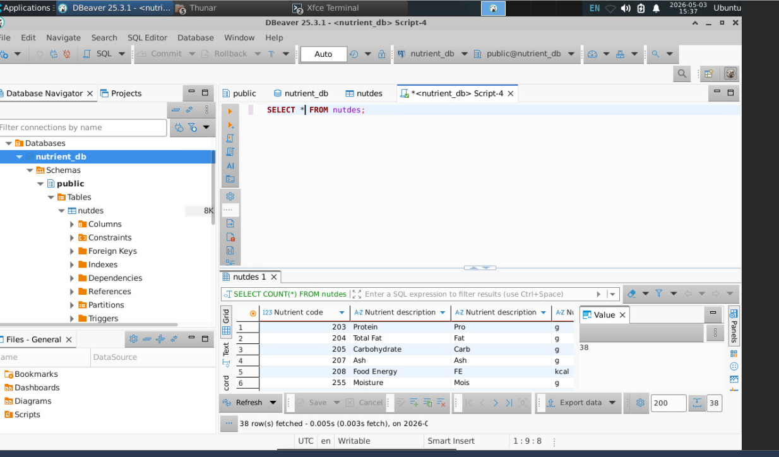
4. Database Backup using pg_dump
A backup of the database was created using the pg_dump tool. This backup file contains the table structure and data, which can be used for recovery or version control. The file was saved with the required naming format and uploaded to a GitHub repository.
